# XRP Price Primed For $20 Climb By End Of 2025

* **New chart trends indicate that** [**XRP price**](https://blockzeit.com/currencies/xrp/) **is priming up for a significant recovery.**
* **The climb could position it to a double-digit price by the end of the year or up to $20.**

## XRP Price to $20

[Ali Martinez](https://twitter.com/ali_charts/status/1891037046665277657), a renowned cryptocurrency trader and analyst on X, stated that the XRP price chart just entered a cup-and-handle pattern. The breakout of its value at that point could position it to rally back to $3.35, a price the token lost last January.

The prediction brought renewed optimism to XRP despite the market sentiment continuing to hover within a “Neutral” level in the [Crypto Fear & Greed Index](https://alternative.me/crypto/fear-and-greed-index/) at 51 today. Last week, the public pulse toward digital assets entered the “Fear” zone at 43 as traders and investors remained on guard following the [massive liquidations](https://blockzeit.com/2-19-billion-in-bitcoin-and-crypto-rekt-as-market-shifts-sentiment/) at the start of the current month. It substantially dropped from the “Extreme Greed” rating of 77 last month.

Responding to Martinez, [Jay Nisbett](https://twitter.com/JayNisbett/status/1891099985585774848), entrepreneur and President of The 407 Group, reminded people that XRP has also entered a [hammer candlestick pattern](https://blockzeit.com/xrp-price-teases-a-break-to-3-40-with-the-emergence-of-a-bullish-indicator/) on the monthly chart. He said it would be interesting to see what would come next of it, as it hints at a “couple hundred percent” move in the next few months. In addition, if the momentum carries out, he claimed the token could be trading by over $20 by the end of 2025.

## XRP Price Performance Today

As of publication at 4:00 AM UTC on Monday, XRP was valued at $2.71 in exchanges. It exhibited over a 2% reduction in value in the daily chart and 16% in the one-month chart. However, it increased by more than 13% and 384% in the seven-day and one-year trends, respectively.

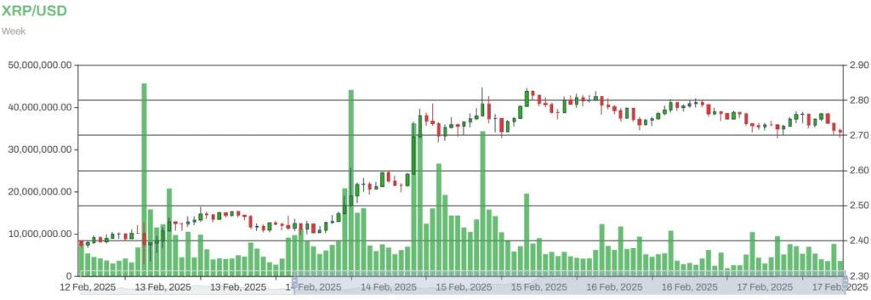XRP to USD

XRP only went between a $2.70 low to a $2.80 high in the last 24 hours. The lack of considerable price action led to the token’s trading volume dropping by 18% in a day, as it only managed to move around $3.42 billion worth of its assets across wallet addresses.

## Reinforcing the Bullish Sentiment

Amid the latest developments from a technical standpoint, XRP price could further leverage Ripple’s advances in cross-border payments and push for a more crypto-friendly regulatory climate in the US.

RLUSD presently has a $53.1 million market cap. Its adoption could be boosted by [Unicambio’s recent Ripple Payments adoption](https://blockzeit.com/ripple-strengthens-presence-with-unicambio-partnership/) for cross-border transactions across Portugal and Brazil last week as well as [Ripple’s license approvals in the US](https://blockzeit.com/xrp-price-gets-15-boost-from-ripples-us-license-approvals-and-whale-purchases/) at the end of January.

Meanwhile, its corporate executives appear to be on track in working with various governments to propel digital asset adoption to new heights, especially in the US. [Brad Garlinghouse](https://twitter.com/bgarlinghouse/status/1890172132380078499), the company’s CEO, confirmed on Friday that he and Ripple CLO Stuart Alderoty recently returned to Washington, D.C., in order to support and discuss the ongoing bipartisan legislation toward “constructive and pro-innovation regulatory frameworks for crypto.” This could pave the way for the eventual dismissal or settlement of the US Securities and Exchange Commission (SEC) case against Ripple and approval of the pending [XRP exchange-traded funds (ETFs)](https://blockzeit.com/xrp-etfs-a-sign-of-the-end-of-the-sec-v-ripple-case/).