# PancakeSwap (CAKE) Gets Over 18% Boost After $1T Milestone And CZ Post

* [**PancakeSwap**](https://blockzeit.com/currencies/pancakeswap-token/) **(CAKE) continues to gain significant momentum after crossing the $1 trillion historical trading volume milestone.**
* **Former Binance CEO Changpeng Zhao acknowledged its ecosystem’s latest achievement on social media.**

PancakeSwap (CAKE) emerged as one of the top performers in the last 24 hours. This came after a major milestone in its ecosystem and acknowledgment by none other than former Binance CEO [Changpeng “CZ” Zhao](https://blockzeit.com/changpeng-zhao-czs-influence-fuels-bnb-chain-popularity-surge/).

## PancakeSwap (CAKE) Performance

Riding high on PancakeSwap’s historic achievement, CAKE welcomed the week with an over 18% surge from a $2.47 low to a $2.93 high. It remained within the $2.74 mark as of Monday morning, locking in around 10% of its daily gain. The figures elevated its price above 61% in a week and 14% in a month. However, it held almost the same value year-over-year (YoY).

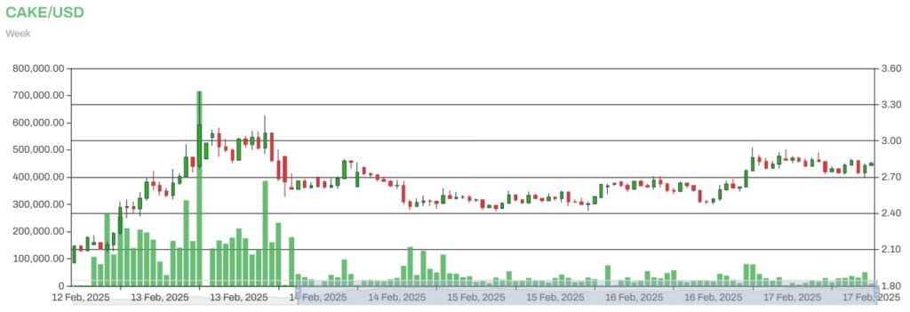CAKE to USD

CAKE experienced a tremendous rise in 24-hour trading volume, which helped propel its price today. Within the period, $434 million worth of the crypto asset moved between wallet addresses, representing an increase of over 30%. Meanwhile, the latest developments boosted the market cap of its 300.37 million token supply to $826.88 million.

Despite its major rally, CAKE is still a far cry from its all-time high of $44.18 four years ago. However, the crypto community is bullish about its prospects in the long run, especially with the growing recognition and adoption of [Bitcoin](https://blockzeit.com/currencies/bitcoin/) (BTC) and mainstream altcoins by institutional investors.

## Behind the Rally

PancakeSwap recently celebrated a key milestone in its token ecosystem. On Sunday, CAKE finally tapped the $1 trillion figure in its cumulative trading volume based on [DeFiLlama](https://defillama.com/dexs/pancakeswap) data. This expands the gap in its all-time trading volume against other key players in the sector, such as [Uniswap](https://blockzeit.com/currencies/uniswap/)’s (UNI) $457 billion and [Raydium](https://blockzeit.com/currencies/raydium/)’s (RAY) $463 billion historical trading volumes.

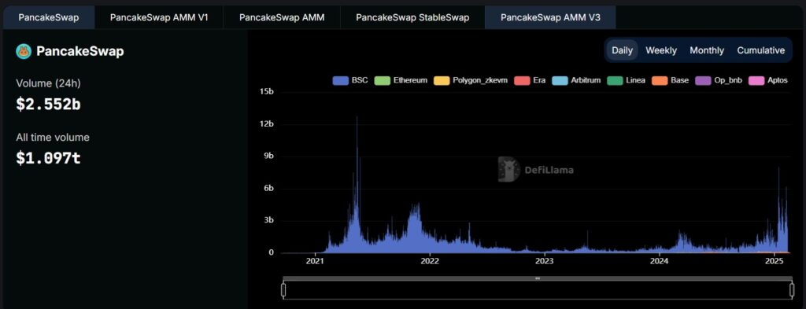Source: DefiLlama

At present, PancakeSwap is already nearing the $1.1 trillion range. That’s nearly a $100 billion accumulation in just a day.

Joining the celebration was CZ. The former CEO of the world’s largest crypto exchange reposted the congratulatory remarks of the pseudonymous [PancakePug](https://twitter.com/PANCAKEPUGBR/status/1891142017318617573), PancakeSwap’s blockchain developer, which further triggered more retail interest in CAKE.

Source: PancakePug via X

Interestingly, PancakePug’s post came with CZ’s tweet in February 2021. Just months after the token’s launch in September 2020, Zhao congratulated the PancakeSwap team for crossing a billion-dollar market cap. This serves as a reminder of the rising demand for the digital asset and its underlying technology, as well as how far it has gone in the last four years.