# MELANIA And LIBRA Creator Claims To Have Bought His Way To The Inner Circle Of President Milei

* **The rabbit hole just got deeper with the leakage of a text conversation between Hayden Davis and an unnamed individual, claiming that the LIBRA project lead paid his way off to get the endorsement of President Javier Milei.**

The plot thickens in the [LIBRA fiasco](https://blockzeit.com/javier-milei-suffers-backlash-from-4b-memecoin-scandal/). A leaked text message revealed Hayden Davis, CEO of Kelsier Ventures (based on his now-deleted LinkedIn profile), has bought his way into Argentina President Javier Milei’s inner circle. This was instrumental in influencing the country’s leader to promote his meme coin project.

## Davis Gaining Influence Over President Milei

In an alleged text conversation exposed by [Coindesk](https://www.coindesk.com/business/2025/02/18/libra-token-s-co-creator-bragged-of-sending-money-to-argentine-president-milei-s-sister), Davis bragged to an unnamed individual how he wriggled his way into Argentina’s highest public office. He proudly told the person that he paid Milei’s sister to get the president to do what he wanted. The crypto personality also claimed that the deal enabled him to have an in-person meeting with President Milei and ask him to post about the LIBRA project.

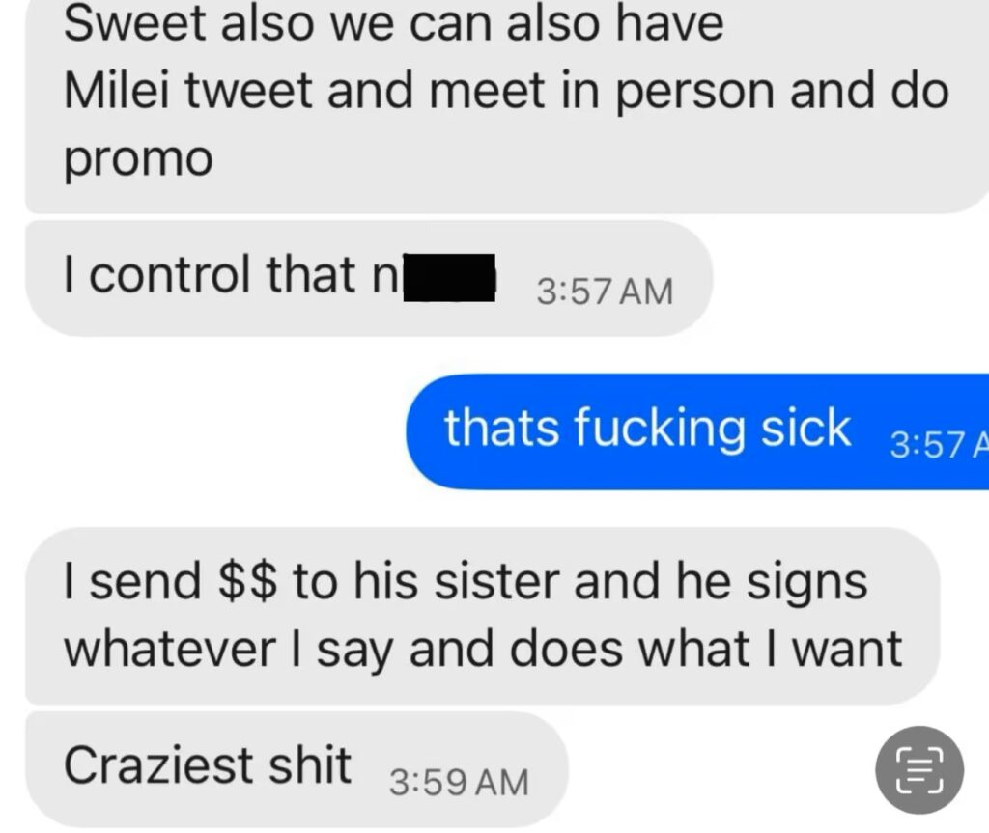Hayden Davis Leaked Text Messages (Source: Coindesk)

It should be noted that an undated photo of Davis and President Milei circulating online suggests that they have met at some point. It’s unclear whether it had anything to do with the LIBRA project.

Hayden Davis and President Javier Milei

The source, however, asked to remain anonymous.

Kelsier Ventures and its associates reportedly pocketed over $100 million from LIBRA’s initial surge. Meanwhile, Davis previously confirmed in an interview with Stephen Findeisen, a.k.a. Coffeezilla, about [sniping MELANIA](https://blockzeit.com/libra-and-melania-link-uncovered-developer-admits-to-sniping-own-token/).

## Spokesperson Denies Davis’ Claim

Milei had only one sister, Karina Milei. She was born two years after the incumbent president, and she is currently serving as the General Secretary of the Presidency of the Argentine Nation.

In the ensuing fallout, Michael Padovano, Davis’ spokesperson, explained that LIBRA’s creator doesn’t recall sending the supposedly leaked messages. In addition, Davis said he doesn’t have any record of the controversial text messages on his phone.

Moreover, Davis expressly denied paying the president or his sister for the promotion of LIBRA. He also clarified that the Milei siblings never asked for payment in relation to the meme coin project.

Davis pointed out that the only concern of the Mileis was the fact that LIBRA would benefit Argentina’s people and economy. Furthermore, he blamed the political opposition for the controversy, saying the accusation was just a “politically motivated attack on President Milei.”

The presidential sister declined to comment on the matter as of writing. On the other hand, President Milei has already called a probe into the issue and is now facing fraud allegations.