# LIBRA And MELANIA Link Uncovered, Developer Admits To Sniping Own Token

* **A crypto sleuth connected** [**LIBRA**](https://blockzeit.com/javier-milei-suffers-backlash-from-4b-memecoin-scandal/) **and MELANIA to a common wallet address, strongly suggesting that the same group of people was operating behind the projects.**
* **Hayden Davis, an entrepreneur and point person in** [**MELANIA**](https://blockzeit.com/trump-and-melania-tokens-draw-flak-from-crypto-community/)**, admitted to sniping the token linked to the US First Lady for quick and huge gains.**

The plot thickens in LIBRA’s botched token launch. Crypto sleuths recently uncovered damning evidence linking the new memecoin Argentina President Javier Milei earlier supported to US First Lady Melania Trump’s Official Melania Meme (MELANIA) token.

## LIBRA and MELANIA Link

Following the trail of breadcrumbs in the transactions of LIBRA, Bubblemaps exposed that the Milei-endorsed token was tied to the same team responsible for MELANIA. A significant chunk of their activities apparently centered on a single address referred to as “OxcEAe.”

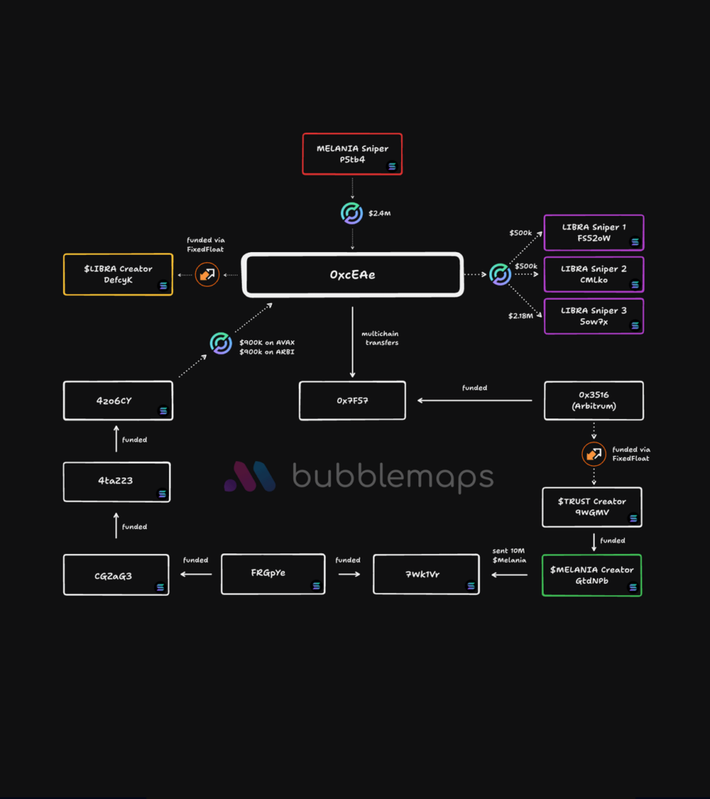Source: Bubblemap via X

According to [Bubblemap’s diagram](https://twitter.com/bubblemaps/status/1891289507338580028), the wallet in question executed a sniping activity on MELANIA during its launch on January 19. The move resulted in an easy $2.4 million gain for the perpetrators, which they immediately redirected to an Avalanche (AVAX) wallet. The people behind the transactions notably utilized multiple funding transactions and cross-chain transfers in an effort to obscure their tracks. They allegedly took over $87 million upon cashing out their [USDC](https://blockzeit.com/currencies/usd-coin/) and [Solana](https://blockzeit.com/currencies/solana/) (SOL) from the token’s liquidity pools.

After the MELANIA hustle, the team’s attention turned to LIBRA. The group employed the same strategy for a quick $6 million from the infamous Argentine token. In addition, the source noted that several entities made approximately $107 million from the meme coin’s insider trading, which wiped over 94% of the crypto’s value within four hours post-launch.

What’s more, Bubblemap connected the devious OxcEAe wallet to other pump-and-dump activities involving tokens such as TRUST, KACY, VIBES, and Robinhood (HOOD).

## MELANIA Creator Admits to Sniping Own Token

In an interview with Stephen Findeisen, a.k.a. [Coffeezilla](https://www.youtube.com/watch?v=EqizJTbxAEM), Hayden Davis, one of the people reportedly behind the controversial tokens within Kelsier Ventures, confirmed his role with the projects. In the same conversation, he admitted about his team sniping MELANIA for personal gains.

Findeisen didn’t divulge some parts of their discussion, though, as Davis asked them to be off the record. Hence, it wasn’t entirely clear how they influenced Milei to be their temporary KOL (key opinion leader) for LIBRA. Nevertheless, one photo has been floating around online featuring MELANIA’s main personality and the Argentine president, which could hint at a deeper rabbit hole in the ongoing memecoin scandal.

https://www.youtube.com/watch?v=EqizJTbxAEM