# ****Does FLOKI Price Have A Chance Of Ever Hitting $0.001?****

[**FLOKI**](https://blockzeit.com/currencies/floki/) **trends within a bearish channel, but some crypto analysts are triggering optimism for the token’s potential jump beyond its current all-time high.**

FLOKI indeed displayed a remarkable performance last year. The token managed to climb by over 1,000% from its 2024 dip toward a new all-time high (ATH) of $0.0003462 by June.

After months of decline, it [rallied again by November to December](https://blockzeit.com/analyst-uncovers-date-when-floki-will-pump-over-750/), but failed to emulate [Bitcoin](https://blockzeit.com/currencies/bitcoin/)’s (BTC) series of spikes to new historic highs during the same period. Since then, it once again trended on a bearish path.

Now, FLOKI once again treads on a state of uncertainty, with its loyal community eagerly awaiting reassuring news.

## Market Saturation Affecting FLOKI

FLOKI has immediately positioned itself in the spotlight with its interesting value proposition. After all, it combines the cultural and viral appeal of meme coins with a promise of utility.

So far, it has managed to build a massive following thanks to its superb marketing efforts and strong community support. In fact, its loyal fanbase has been very active on social media, especially on X.

However, the token remains over 70% down from its historic high. As of Tuesday evening (UTC), it is trading around the $0.000091 range on the red candle.

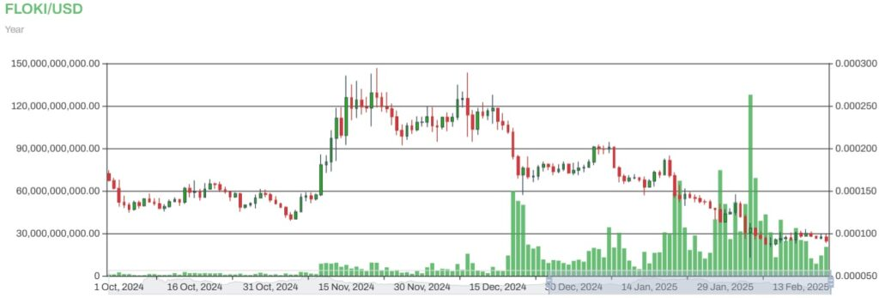FLOKI to USD

FLOKI's long-term price action hasn’t been promising as well. At this rate, it's around 1.7% down in the weekly mark and 42% in the monthly chart. Its one-year movement is still in the green by over 168% but shows signs of continued narrowing down along the way.

Analysts believe the saturated market for meme coins is heavily weighing its price. It’s made worse by the strong dominance of Bitcoin in the crypto market, which is further quashing hopes for an altcoin season this year.

The state of uncertainty is best illustrated in the [Crypto Fear & Greed Index](https://alternative.me/crypto/fear-and-greed-index/#google_vignette), which resumed its move across a “Neutral” level at 47 points on the scale. This has been a significant decline from the “Extreme Greed” score of 77 last month.

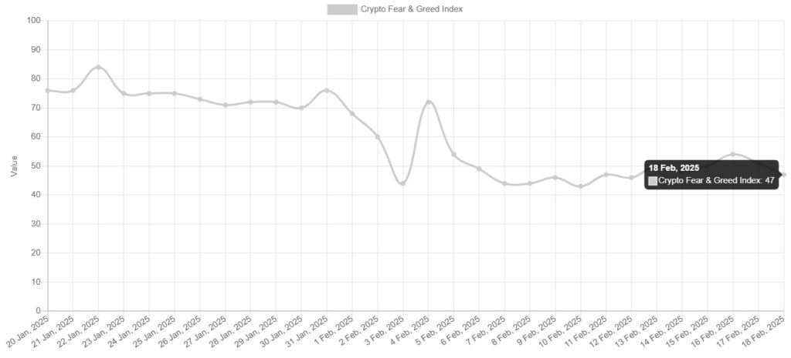Crypto Fear & Greed Index (Source: Alternative)

## Popular Traders Spark Hope for FLOKI Price Recovery

Despite the disappointing developments, some popular traders and analysts on X have recently aired their bullish outlook for the crypto community’s beloved Viking dog-themed meme coin.

Today, the pseudonymous [Master Kenobi](https://twitter.com/btc_MasterPlan/status/1891902601706287494), an active social media personality with a penchant for long-term crypto projects, presented a historical chart showing FLOKI’s trajectory since launch. According to his chart, the digital asset tends to make huge recoveries between 1,200% and 2,050%, following a 77% to 98% downtrend between 230 and 245 days.

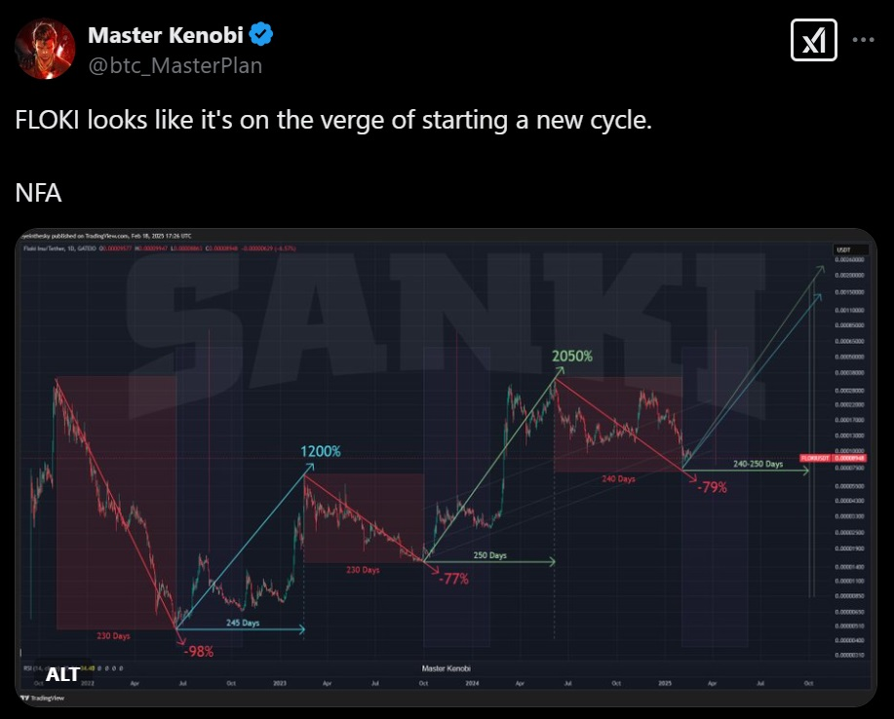FLOKI Price Cycle (Source: Master Kenobi via X)

If the pattern holds, FLOKI could enter another bull cycle around March, propelling it to new record heights above $0.001.

[Ali Martinez](https://twitter.com/ali_charts/status/1890643956586983922), a popular trader and analyst on X, also confirmed FLOKI’s potential bounce later this year. However, he warned the crypto community to brace themselves first for a likely dip to $0.000042 before reaping the rewards.

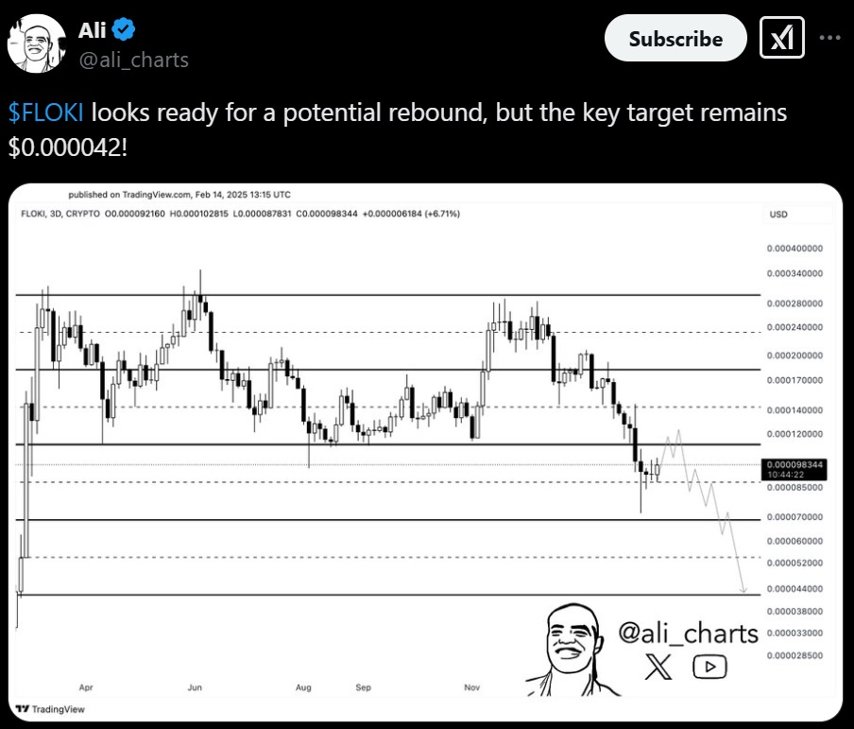FLOKI Price Prediction (Source: Ali Martinez via X)